**An automated multiplexed turbidometric and data collection system for measuring growth kinetics of anaerobes dependent on gaseous substrates**

Nicholas Elliott, Jonathan Forbes, Robert Petersen, Nejc Stopnisek, Fred Taub, and David A. Stahl

**Abstract**

**Introduction**

A variety of automated systems for monitoring microbial growth based on changes in turbidity are available, most using a microtiter plate format for multiplexed analysis of cultures (8). However, such systems are generally not suitable for monitoring the growth of anaerobes, particularly those that require a gaseous substrate for growth or depend on a close hydrogen-based syntrophic coupling, upon which many anaerobic microbial food webs depend. In addition, the slow growth of many fastidious anaerobes requires that growth be monitored continuously over multiple day periods. As part of our studies of simple microbial communities composed of hydrogenotrophic methanogens coupled with facultative syntrophs (*Desulfovibrio* species) we developed a multiplexed monitoring system that accommodates up to 64 pressurized batch culture growth vessels (“Balch” tubes) on a remotely controlled shaking platform. Turbidity is monitored at defined time intervals by suspending shaking and raising the platform vertically for a time sufficient to clear tubes of bubbles before reading optical density via paired sensors positioned on opposite sides of each tube receiver. Sensor data is logged automatically on a database server through a wired Ethernet connection. A custom program displays the growth data in real time, converts sensor data to optical density, calculates changing growth rate through time, and offers direct comparisons of growth kinetics of individual cultures within or between different growth experiments. We here describe the system architecture and its application for the accurate and precise determination of the growth kinetics of model microbial communities composed of the hydrogenotrophic methanogen *Methanococcus* *maripaludis* (Mm) growing in syntrophic association with *Desulfovibrio* *vulgaris* (Dv).

**Materials and Methods**

**System overview**. The Optical Density Investigation (ODIn) system was designed for use with standard Balch tubes (18x150 mm stoppered glass anaerobic culturing tubes) commonly used for culturing fastidious anaerobes. Balch tubes are engineered to maintain anaerobic microbial cultures by use of removable rubber stoppers secured using crimped aluminum seals (5) which provide an impermeable barrier to the external environment. Sample tubes are contained in machined, modular resin tube racks engineered to accommodate eight individual tubes in a 1 x 8 linear layout (FIGURE S.XX). Each tube rack integrates eight separate sensors each consisting of a light emitting diode (LED) and a receiving phototransistor wired to a sensing circuit board for measurement of each sample channel. Tubes are secured inside each rack by a removable top cover located at the insertion end of the rack and stabilized using O-rings channeled into each tube rack cavity. The removable top cover has openings at each tube position to allow access to the rubber stopper for sample access during an experiment. In total, the system is comprised of eight tube racks which are secured to the orbital shaker by means of a slide in cabinet fastened to the shaker table platform and are each attached with four socket screws to the cabinet (FIGURE S.XX). Each eight sensor set functions through a common circuit board that is attached to the interior of the tube rack base accessible through a removable bottom plate secured with four socket cap socket screws. For continuous sample tube content homogenization a New Brunswick Innova 2300 orbital shaker was modified for attachment of a platform that secures the housing cabinet and lifting mechanism (Figure 3). A linear actuator, directed by the microcontroller and communicated through a 5-pin Conec Female socket M12x1threaded connector, lifts the platform from its horizontal position to approximately 50-degrees prior to each series of readings. Once all 64 sensors have completed their readings at each channel position those values are communicated to the microcontroller through each of the eight tube racks individual DE-9 cable. The microcontroller initiates each data collection experiment and records sensor output to a local SD card. An attached Arduino Ethernet Shield transmits the data to a remote server through a wired Cat6 Ethernet cable. Upon completion of the data acquisition and reporting procedure the linear actuator retracts returning the platform to a horizontal position and the shaker table is then reactivated.

The control elements of the system are housed in a system control box separate from the orbital shaker/tube rack cabinet apparatus. One side of the control box provides communication connections to the eight tube racks by placement of eight DE-9 female receptacles for serial cable connection. System power is provided by a 12VDC 100W panel mount power supply which is itself powered through an externally placed IEC 60320 C13 120V female receptacle that connects to a 120VAC wall outlet. The control box provides operation interfaces that includes a system status feedback display by an LCD screen, a knob controlling a four position rotary switch for selecting preset sampling time intervals, a knob controlling an eight position rotary switch for selecting a single tube rack to display the real-time sensor output values during a debugging mode, a two position toggle switch for selecting between device modes “Run” and “Debug”, and a push button “Pause” switch for system pausing and activation (Figure 4). Communication with the microcontroller is achieved by a cutout access on the control box to the Arduino Mega’s USB Type-B embedded port. Access to the SD card for local data storage is provided by a cutout on the control box side which allows an SD card to be inserted and removed from the connected SD Data Logger Shield. Ethernet communication is provided by a control box cutout to allow access to the Ethernet Shield embedded RJ-45 Ethernet port. The electrical connections for orbital shaker table activation/deactivation are joined through an interrupting relay controlled by the microcontroller. A full description of the device and fabrication is provided in supplementary information.

**Cultivation and statistical analysis.** Culture medium was prepared as previously described (Lim et al. (2014), containing 7.5 mM lactate and 5 mM sulfite, 30 mM lactate and 15 mM sulfate,10 mM acetate or 30 mM lactate for the growth of Dv and Mm monocultures and cocultures, respectively. Sulfite, rather than sulfate, was used as electron acceptor for isolating evolved clonal lines of Dv since many had lost the ability to respire sulfate (2). Cultures were passed at least twice before inoculating five cultures tubes for replicate measurement of growth kinetics in the ODin system. The cultures were grown with continuous shaking of 300 rpm at 37 °C for up to 3 days, measuring optical density (OD600) in 20 minute intervals. Sensor readings (mA) were converted to OD600 using custom software in FileMaker (see supplementary information for details) and exported and analyzed using different statistical software. Growth kinetics were plotted and analyzed using the grofit (3) and ggplot2 (4) packages developed for R-project (R version 3.2.3, [https://www.R-project.org/](https://www.r-project.org/)). As figure 2 demonstrates, the ODIn system offers a precision and sensitivity sufficient to resolve minor differences in growth rates and yields. These two growth parameters provide the most consistent and reproducible data, whereas the lag phase is less reproducible, presumably as a consequence of slight variations in inoculation.

**Results and Discussion**

This ODIn system uses commercially available electronic components and advances the method of recording anaerobic growth kinetics by providing high sampling frequency over extended time periods without the disruption (or investigator fatigue) commonly associated with manual measurements. The system uses a microcontroller and paired optical emitter and collector sensors embedded within each tube holder to measure optical density changes within each sealed tube. Optical density for each culture tube is measured by one of the 64 integrated sensor circuits fixed at the tube rack position the culture tube occupies. Sampling frequency is controlled by microcontroller software, with default settings of 5, 20, 40, and 60 minute reading intervals. Culture tubes are held in a horizontal position to provide complete mixing of the liquid contents by orbital shaking to allow homogenous sample conditions and to prevent aggregation of cellular communities into flocs which could occlude the sensor path resulting in inaccurate reporting of the average optical density of the whole tube. Prior to reading each of the 64 positions, the orbital shaker is deactivated by interruption of its power supply by the microcontroller controlled relay. The hinged platform lid is then raised by extension of a pivoting electrical linear actuator affixed to the interior base of the lifting platform by a fixed linear actuator bracket and the underside of the hinged lifting platform using a custom scissor hinge mechanism. Readings of all sensor pairs are completed within a minute, and values recorded both on the local SD card and reported by the Ethernet Shield using a UDP datagram to a remote server through the Ethernet connection. The data is stored and continuously plotted with custom software developed on FileMaker Advanced version 14 (FileMaker, Inc., USA). Further details are provided in the supplementary information.

The utility of the system was evaluated by comparative analysis of available cultures previously shown to exhibit minor to significant differences in growth rate and yield. These were obtained as part of a long-term evolution study of a simple microbial mutualism established between *Desulfovibrio vulgaris* Hildenborough and *Methanococcus maripaludis*. Our prior studies had shown that this forced mutualism, based on interspecies hydrogen transfer, improved rapidly through adaptive evolution, increasing several fold in growth rate and yield within a few hundred generations of initial pairings (6). Ongoing analysis of mutations that accumulated in replicated cultures suggests that both common and divergent patterns of mutation accumulation in different populations are associated with growth improvement. For example, many *Desulfovibrio* in replicated evolution lines lost the capacity for sulfate respiration as a consequence of nonsense mutations in genes coding for sulfate activation and reduction to sulfite. Resolving the contributions of those and other mutations to community improvement is complicated by the large number of mutations present at low frequency in each evolution line (as measured by total community genome resequencing), reflecting the emergence of multiple genotypes of evolved *Desulfovibrio* and *Methanococcus* populations (7). In order to identify mutations within a single evolved genotype contributing to community growth improvement, we isolated clones of evolved *Desulfovibrio* and *Methanococcus* at different times (generations) of evolution from different replicated evolution lines. Growth kinetics of individual clones in monoculture, and when paired within and between different evolution lines were measured using the ODin system. A subset of those data are included in this report, showing that the system offers the precision, sensitivity, and accuracy necessary to resolve cultures that differ only slightly in growth rate and yield (Figure 2).

The growth data now provides an essential foundation for identifying mutations and combinations of mutations, within or between evolved clonal populations of *Desulfovibrio vulgaris* and *Methanococcus maripaludis*, contributing to even minor improvements in mutualistic growth. We anticipate those data will offer improved understanding of the adaptive response of related natural populations to environmental change or perturbation, offering both a more mechanistic and predictive understanding of microbial community system response to natural or imposed change. Since the ODin system is designed for growth studies in pressurized vessels, we anticipate that it will also serve for studies of other microorganisms that require, or have the capacity to use, gaseous substrates for growth, such as methanotrophs and Knallgas—bacteria, or communities such at examined here that are dependent upon gas exchange.

**Figures and Table****s**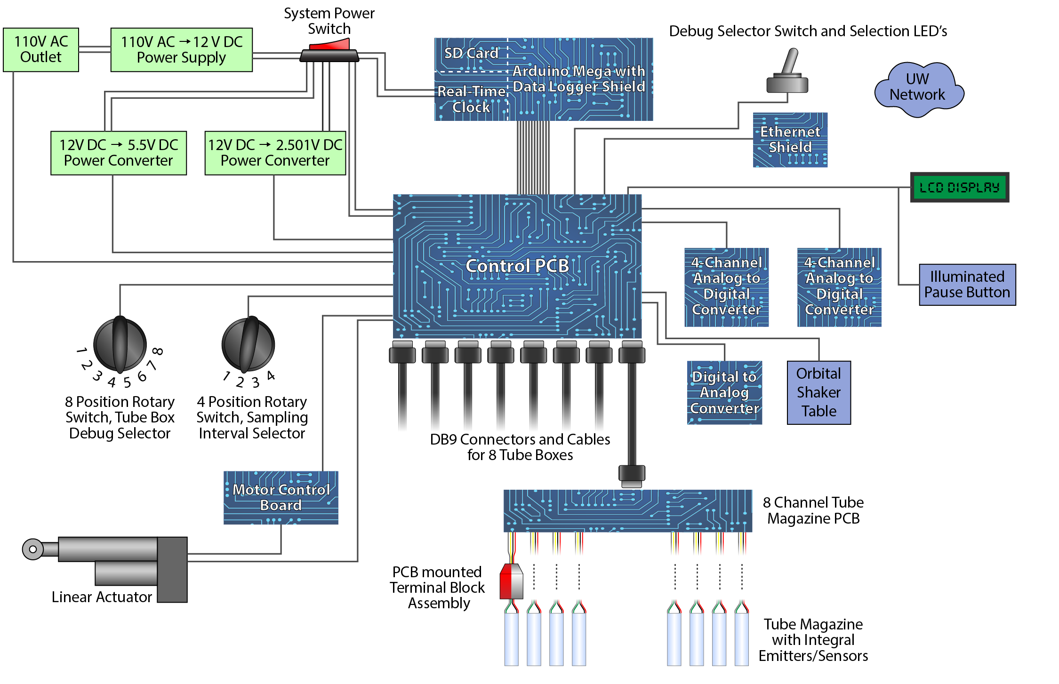**Figure 1*.****Schematic overview of system control and operation elements for ODIn system Control elements are housed separately from the operational sensors which are tethered to the control box using 9-pin serial cables.*

Macintosh HD:Users:Nejc:Desktop:HA2_Mp.pdfMacintosh HD:Users:Nejc:Desktop:HA2_DvH.pdfMacintosh HD:Users:Nejc:Desktop:HA2_pairings.pdf

**Figure 2.** *Growth measurements of the selected Dv (A) and Mm (B) clonal isolates and corresponding pairings (C) from the HA2 evolution line as presented by their growth rates (x-axis) and growth yields (y-axis). EPD corresponds to the End Point Dilution from which the clonal isolates derived from. Error bars represent standard errors of three to five replicate cultures.*

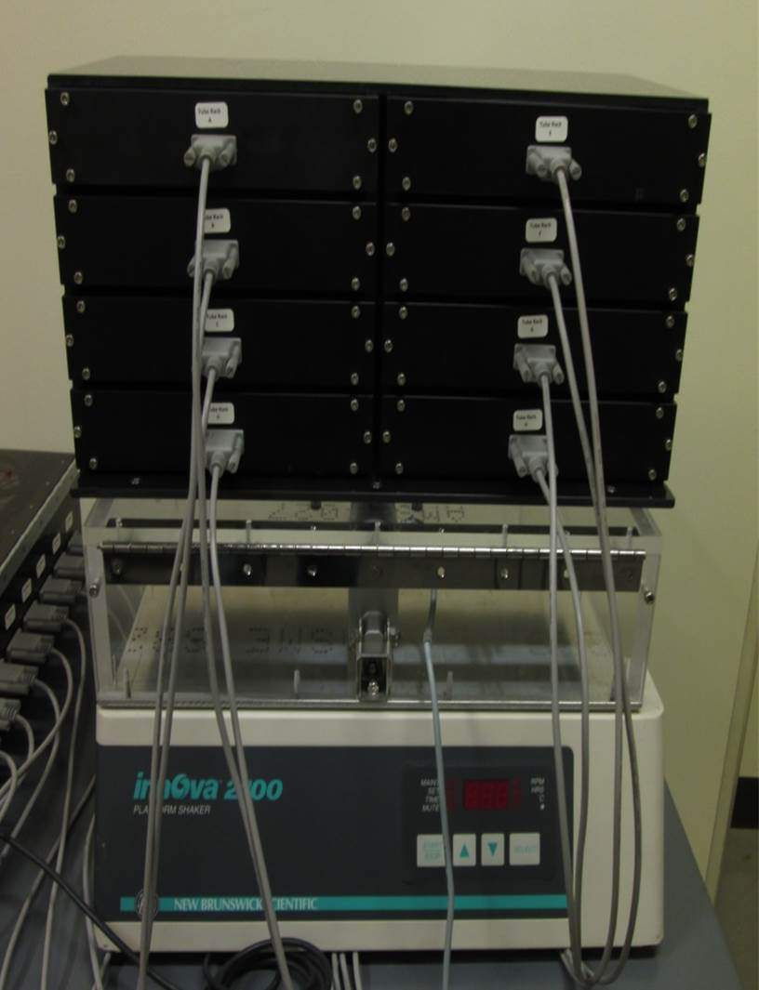

**Figure 3.** *Assembled operational elements of ODIn system attached to modified New Brunswick Innova 2300 Orbital shaker. Eight tube racks secured to slide in cabinet attached to acrylic lifting platform hinged lid which is raised by pivoting electric linear actuator. Each tube rack houses eight unique biological samples with a fixed position sensor and is connected to the control box by serial cable.*

**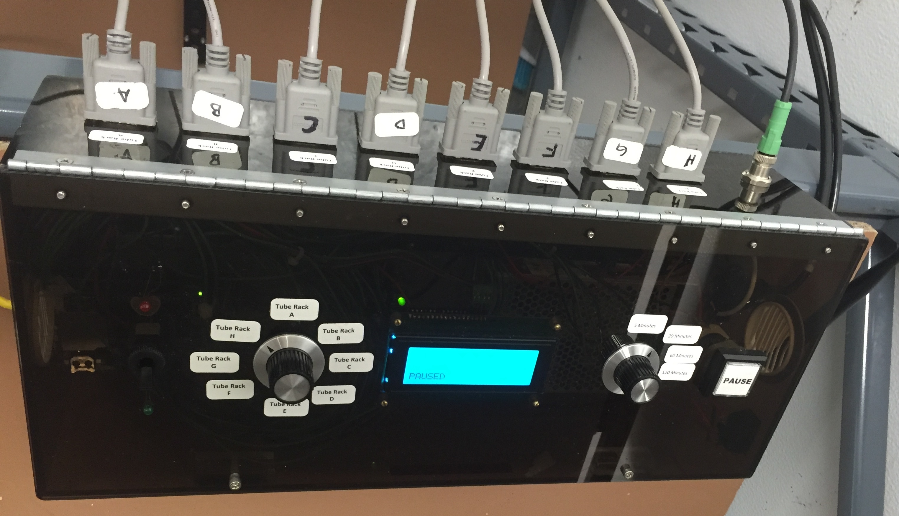**

**Figure 4.** *Control box for ODIn system. Interface components are placed on the exterior hinged lid of the box and allow users to select system functions for experimental operation or debug mode, tube rack LCD output, sampling interval time, and start/pause of system. Tube racks are connected individually by serial cables and lifting linear actuator by a 4-pin LEMO connector.*

**References**

1. Lim, S., S. Stolyar, and K. Hillesland, Culturing Anaerobes to Use as a Model System for Studying the Evolution of Syntrophic Mutualism, in Engineering and Analyzing Multicellular Systems: Methods and Protocols, L. Sun and W. Shou, Editors. 2014, Springer New York: New York, NY. p. 103-115.

2. Hillesland, K.L., et al., Erosion of functional independence early in the evolution of a microbial mutualism. Proceedings of the National Academy of Sciences, 2014. **111**(41): p. 14822-14827.

3. Kahm, M., et al., grofit: Fitting Biological Growth Curves with R. 2010, 2010. **33**(7): p. 21.

4. Wickham, H., ggplot2: Elegant Graphics for Data Analysis. 2009, New York: Springer-Verlag

5. Balch WE, Wolfe RS. New approach to the cultivation of methanogenic bacteria: 2-mercaptoethanesulfonic acid (HS-CoM)-dependent growth of Methanobacterium ruminantium in a pressureized atmosphere. Applied and Environmental Microbiology. 1976;32(6):781-791.

6. Hillesland, K. L., & Stahl, D. A. (2010). Rapid evolution of stability and productivity at the origin of a microbial mutualism. Proceedings of the National Academy of Sciences,107(5), 2124-2129.

7. Hillesland, K. L., Lim, S., Flowers, J. J., Turkarslan, S., Pinel, N., Zane, G. M., Stahl, D. A. (2014). Erosion of functional independence early in the evolution of a microbial mutualism. Proceedings of the National Academy of Sciences, 111(41), 14822-14827.

8. Takahashi, C. N., Miller, A. W., Ekness, F., Dunham, M. J., & Klavins, E. (2015). A Low Cost, Customizable Turbidostat for Use in Synthetic Circuit Characterization.ACS Synthetic Biology,4(1), 32-38.

***Supplementary information***

**Sensor Circuit Design.** The sensor is comprised of a snap-in mount 880-nm light emitting diode (LED) and a paired phototransistor. Each sensor produces a beam across the diameter of the Balch tube having a path length of 18-mm and operates recording the gradual signal attenuation resulting from growth in the culture tube. This circuit design produces a very low frequency signal, necessitating direct current amplitude sensing to fully characterize the growth kinetics of the cultures. A four-section amplifier bias circuit (Figure S1) was designed to achieve the signal production. One section of this circuit uses a 2.501 V power supply to deliver a constant 833.67 μA to the LED. This constant current supply to the emitter provides constant light output throughout the experiment. As photons from the emitter strike the phototransistor sensor, a small current is generated. Each LED/phototransistor pair used in the device was characterized and selected so that no more than 2.48 mA of current was generated for a tube of uninoculated medium and at least 0.54 mA for a culture of 1.350 OD600 (the highest possible density for the target experiments). A transresistance amplifier converts each 1 mA of current input to a 1 V + 2.501 V output. The added 2.501 V is then immediately removed in the next step of the analog circuit as part of power supply isolation. The signal at this stage of the analog circuit is 1 V for every 1 mA generated in the phototransistor. It is then both amplified and shifted by an amount calibrated to each sensor at the start of each experiment, serving to maximize sensor resolution by generating a signal that better fits the range of voltages read by the 16-bit 5 V ADC. Between the sensing circuit and the ADC is an eight channel multiplexer for selecting each of the eight cultures in each tube rack holder for sampling.

**Sensor Calibration.**  Upon system activation all 64 independent LED/phototransistor sensors are actively powered. Prior to collecting experimental data all sensor emitters must be allowed sufficient time to reach a stable operating temperature which is necessary for consistent light output. Balch tubes filled with inoculated batch cultures to be measured for optical density changes are secured into tube racks for the initial baseline measurement at the beginning of each experiment. Each sensor is independently calibrated for its sample with the aim to equalize all sensing circuit outputs to 0.3 V, corresponding to an ADC reading of 1600. With the caveat that all test tubes contain samples whose optical density at baseline will be at its lowest expected value and will rise within a projected range, each experimental run at this calibration identified ADC value allows for measurements to be recorded within the readable range while providing a small buffer in the event that the optical density decreases a small amount initially. Utilizing this calibration method the range of final voltages (0-5 V) corresponding optical density increases which can be read by the ADC is maximized as the voltage will rise as growth occurs. Calibration is performed on each sensing circuit using a logarithmic algorithm tracking high, low, and testing voltages set initially to the maximum, minimum, and middle voltages programmable by the digital analog convertor (DAC), which are 5, 0, and 2.5 V respectively. Beginning the calibration with the initial testing voltage, the ADC reads the sensing circuit output and if the voltage is too high, then the high voltage is set to the testing voltage and the next testing voltage is set to the midpoint between the high and low voltage values, which for the first calibration step is 1.25 V. If the sensing circuit voltage is too low, the low voltage value is set to the testing voltage, and again the next testing voltage is set to the midpoint between the high and low voltage values. During this calibration the testing point which results in the ADC value closest to 1600 is stored, so by the end of the calibration testing the appropriate calibration voltage has been identified. After each sensing circuit has been calibrated, the ADC value is stored in the program for reference throughout the sampling for setting the sensing channel voltage at each measurement and also sent to the data collection server for inclusion is the data file. Emitter-collector pairs will often calibrate to the same ADC value over the course of many experiments and thus deviations from usual calibration values can be used to identify faults occurring on a specific sensing channel.

**System Operation.** When an experiment is started the system is powered on into a paused state where the sensor circuit is energized but not actively recording sample measurements. The system remains in a paused state to allow the LEDs time to equilibrate to operating temperature and become stable in their light output so that any gradual shift in the light emitted or received is not interpreted as change in optical density. This occurs within four hours when ambient temperature is 37°C. A switch on the control box is used to select between an operational mode where regular measurements occur, are recoded to the onboard SD card and sent to the remote server following calibration and a debugging routine. In the debugging mode the tube racks are elevated using the hinged lifting platform and the output from each tube in an 8-tube rack continuously displayed on the control box LCD screen, with selection of readings from each of the eight racks controlled by a rotary switch on the control box. This procedure allows for immediate sensor value data to be displayed from any sensing channel and is a useful diagnostic tool for identifying faults and determining optical working ranges. The normal data collection procedure operates by first activating the measurement program by depressing the pause button on the control box. This action raises the hinged lifting platform and initiates the calibration procedure on each of the 64 sensing channels.

Once calibration is complete the program takes the first measurement of each sample then reads the status of the four position rotary switch on the control box which determine the sampling interval of programmable preset values of either 5, 20, 40, or 60 minutes. These intervals are configurable in the program software and may be readjusted during an experimental run by switching to any of the four values using the selectable dial. The linear actuator then lowers the lifting platform to horizontal and a countdown commences to the next data collection point. Between data samplings the control box LCD displays the dial selected interval time in minutes and an active countdown in milliseconds of time until next sampling. If the systems pause button is depressed during an active experiment, it will continue to count down to the set data collection time, but will not collect data until the system is un-paused. This allows samples to be removed during an active experiment for external sampling.

When the time interval between samplings is reached, the orbital shaker is depowered and the tube racks raised for the next measurement. To mitigate the effects of random spikes in sensor readings, a total of 20 ADC values are taken for each sensing circuit at each sampling point and averaged for the reported value. All 64 data points, along with the time since testing began, are sent to the data collection server via UDP transmission over an Ethernet network connection. The measurements are also recorded on an onboard SD card in the control box as a backup in a timestamp .CSV file. An onboard real-time clock with coin cell battery backup keeps track of the current date and time. Data is both reported and recorded in the .CSV file format and arranged with the output of each channel’s reading in separate columns. Output data are milliamp values as recorded by the ADC. Upon completion of the experiment each culture is measured at 600-nm in a spectrophotometer (HACH, Loveland, Co), and pre- and post-experiment OD600 values used to convert milliamp values to an OD600 (Figure S2).

**Data Collection.**  The ODIn database archives the data generated by the ODIn system hardware and facilitates its analysis. The database, developed with FileMaker Advanced version 14 and hosted by FileMaker Server v14, operates independently from the ODIn hardware. (FileMaker Advanced is a cross-platform, relational database development application published by FileMaker, Inc. FileMaker Server hosts databases created with FileMaker Advanced making them available to multiple simultaneous users via FileMaker applications for Macintosh, Windows, iOS, or browser-based clients). At its top level, the database is organized by individual experiments. Each experiment corresponds to a single run of the ODIn hardware with sensing channel output data collected for each of the 64 Balch tubes. Metadata for each experiment includes experiment name, description, start and stop timestamps, and the number of measurements collected. This information is displayed in the database’s experiment view. Each experiment in the ODIn database is organized by rack, and each of the eight racks can be given additional descriptive metadata as inputted by the user. In the database, each of the eight racks is divided into records for each of its eight Balch tubes. More detailed metadata can be entered for each tube, including description, media composition, electron donor, electron acceptor, and organism(s). In addition, a notes field is available for each tube, allowing essentially unlimited text entry. Associated with the notes are three image fields, which can be used to store photographs or other images related to a tube. To facilitate the user entry of metadata for each of the 64 tubes, a variety of auto-fill tools have been created for the database. These include the ability to replicate a tube’s metadata entry, with automatic sequential numbering and a “fill-down” button, which will copy the current tube’s metadata to the remaining tubes in the rack. Ease-of-use was a paramount design concern, with the intention of achieving greater accuracy and metadata entry completion. The ODIn database’s rack view (Figure S3) is designed to show, at a glance, the metadata for each tube in a given rack. Many experiments include biological replicates; two or more tubes may be inoculated with the same sample. While it can be valuable to view results for each replicate individually, it can be preferable to average the results of replicates and display them as one. The ODIn database makes it trivial to group replicates together and a simple color-coding system makes the replicate-grouping apparent to the viewer. Up to 32 replicate groups can be created for each experiment. When looking at the ODIn database experiment view, clicking the right-arrow button associated with an experiment triggers two events. If the experiment is still running, the ODIN database will query the data collection server to determine if new data is available and if so, that data will be imported. Subsequently, or if the experiment has already been completed, will switch to a summary view, showing data for all 64 tubes, organized into eight graphs, one for each rack. The ODIn database can graphically display a summary of an experiment’s results, organized by rack, a single rack’s results, a single tube’s results, or the results of any combination of tubes and replicate sets from a single or from multiple experiments. Additionally, a user can choose between growth rate and growth kinetic graphs and specify filters which restrict the graphs to specific time intervals or which specify minimum and maximum values for OD, mA, or growth rate. Any combination of filters may be applied simultaneously. The growth rate graphs display the change in growth rate over time. The growth rate values are averaged using a user-selectable number of readings before and after each time point. Finally, the ODIn database also includes an export tool that allows one-click export of raw data, OD values, or mA values to save at a local machine as a .CSV file for manual data analysis.

**System Components.**  Atmel ATmega2560V microcontroller and Arduino Ethernet Shield are used for employing sensor operation, sampling protocol, data acquisition and reporting, and mechanical operations. One IEC 60320 C13 120 V female receptacle is provided for AC power supply and one NEMA 5-15P 120 V AC outlet connected to a G2R PCB mount relay for shaker table activation/deactivation. One L298 H-Bridge dual bidirectional motor controller is used for operation of an HDA4-30 4-inch stroke linear actuator. Delta Electronics PMT-12V100W1A 100 W AC/DC converter 12 V for the microcontroller and linear actuator power source. Two Texas Instruments PTN78060WAH DC-DC converters take 12 V DC and supply 5.5 V DC power for the sensor circuit and PCB power source, and 2.501 V DC to drive the emitters and provide a reference voltage for power isolation. ADS1115 16-Bit 4 channel Analog to Digital converter and MCP4725 12-bit Digital-to-Analog converter.

**Supplementary Figures**

**Figure S1:** Block diagram.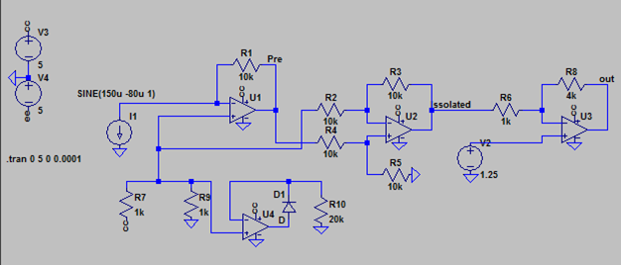

**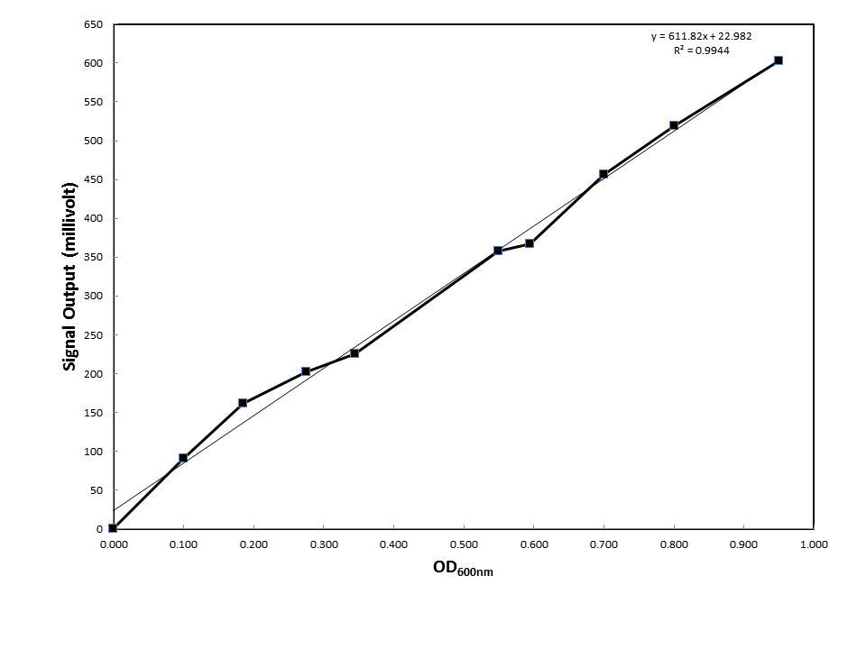**

**Figure S2.** *Linear relationship of sensor output readings (in millivolts) to manual spectrophotometric readings of McFarland standards in stoppered Balsh tubes****.***

**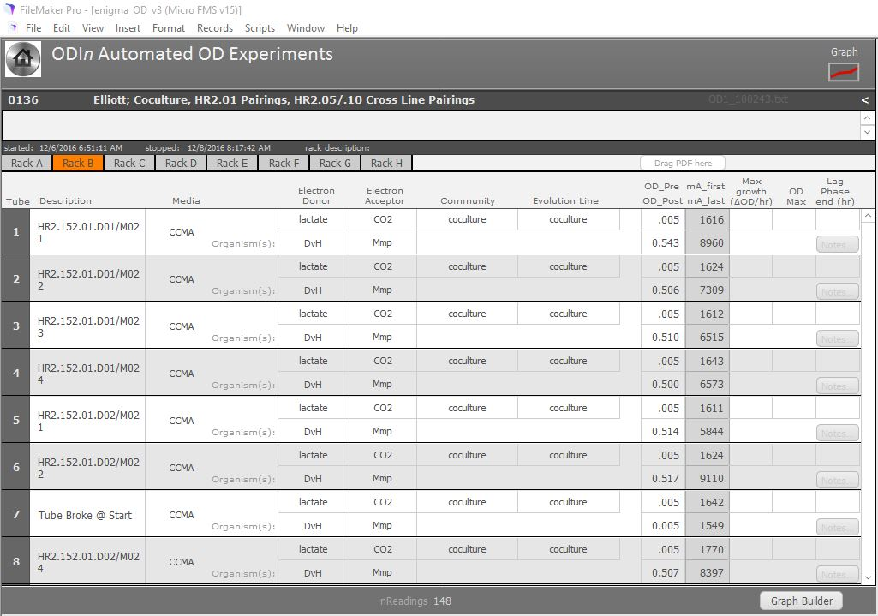**

**Figure S3.** *Tube rack sample metadata display. Selectable tabs provide information for all tube rack channels for a complete eight channel rack.*

**Figures extracted from Petersen’s draft**

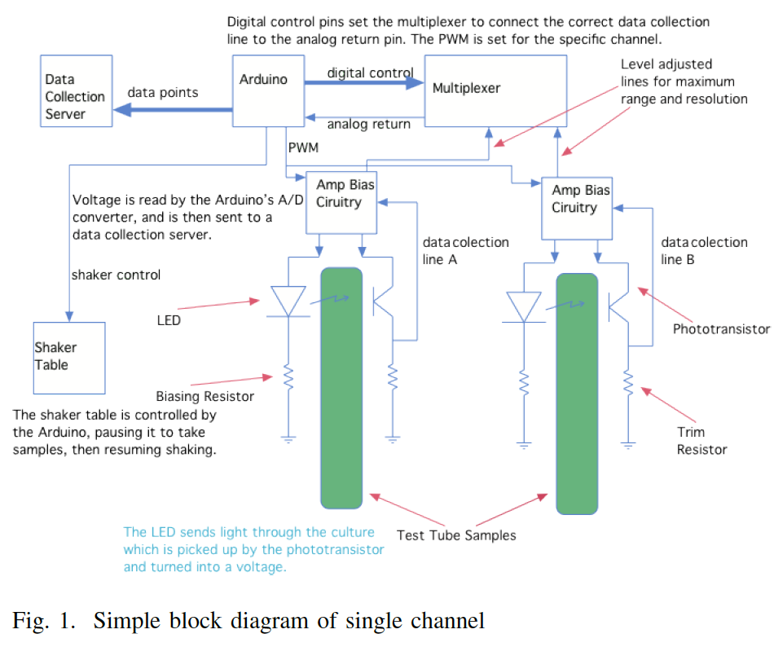

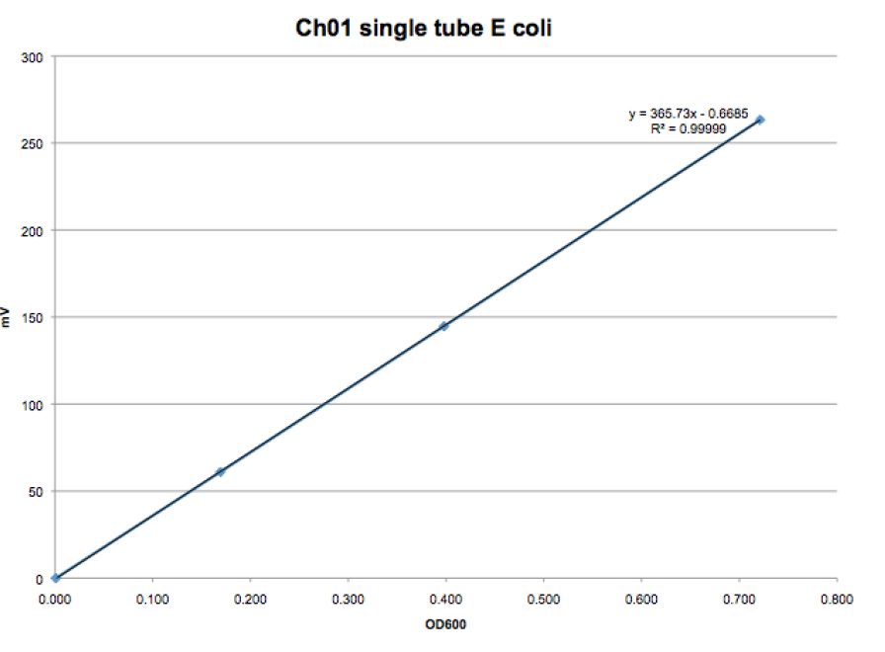

**Flow Diagrams from Jonathan**

Macintosh HD:Users:davidallanstahl:Library:Containers:com.apple.mail:Data:Library:Mail Downloads:CB720038-6E6E-4DCD-AFCC-C2713EE41512:Normal Operating Loop.pdfMacintosh HD:Users:davidallanstahl:Library:Containers:com.apple.mail:Data:Library:Mail Downloads:1F0E4BA8-2AEE-4025-87AC-C346CCCD720B:Debug Loop.pdf

Macintosh HD:Users:davidallanstahl:Library:Containers:com.apple.mail:Data:Library:Mail Downloads:A0B34431-7AAF-4B31-A732-7512951DB42B:Overview.pdf

Macintosh HD:Users:davidallanstahl:Library:Containers:com.apple.mail:Data:Library:Mail Downloads:A736920E-2015-4AFF-9AB9-EFD878075B29:Calibration.pdf

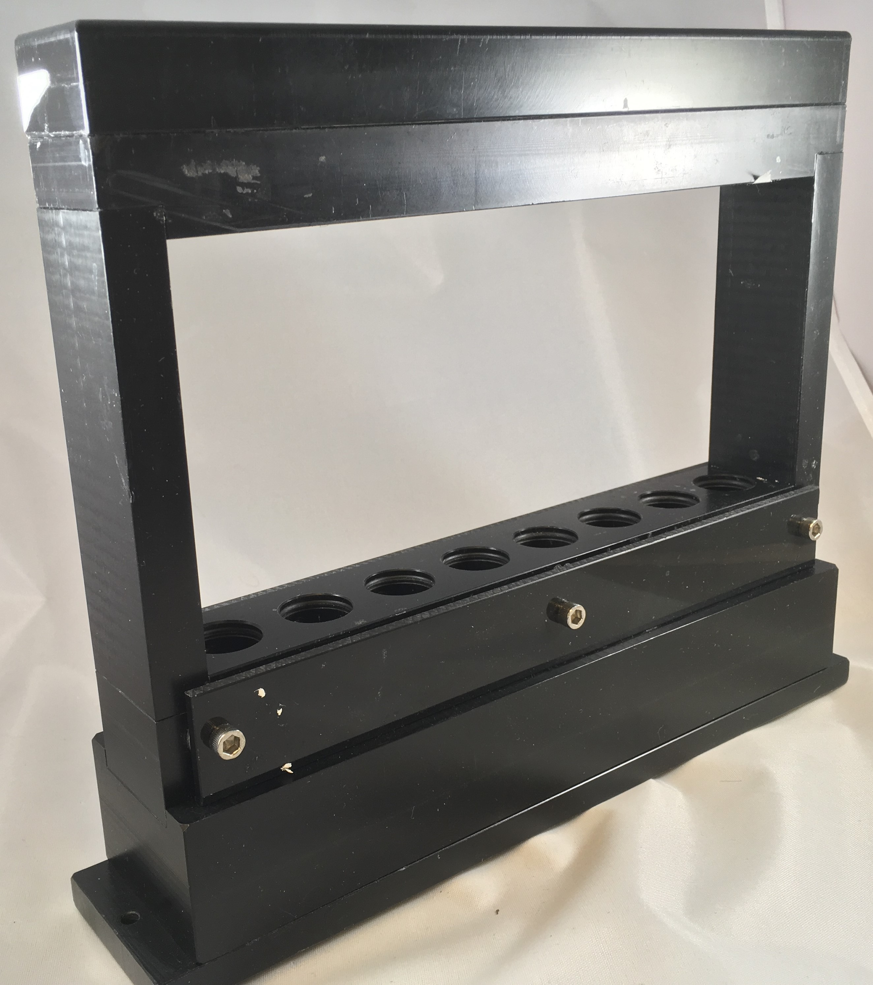

A

